Staying COVID-19 Secure in 2020
We confirm we have complied with the government’s guidance on managing the risk of COVID-19

FIVE STEPS TO SAFER WORKING TOGETHER

We have carried out a COVID-19 risk assessment and shared the results with the people who work here

We have cleaning, handwashing and hygiene procedures
in line with guidance

We have taken all reasonable steps to help people work from home

We have taken all reasonable steps to maintain a 2m distance in the workplace

Where people cannot be 2m apart, we have done everything practical to manage transmission risk

Employer
Astley Bank Hotel
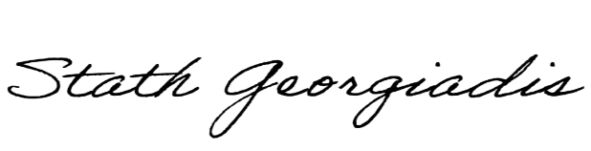
Date
18 July 2020

Who to contact:
(or the Health and Safety Executive at www.hse.gov.uk or 0300 003 1647)

